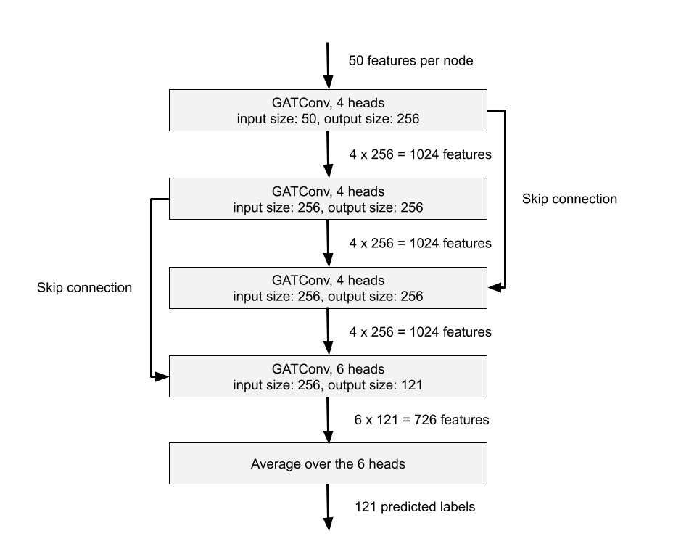

Architecture of the best model (GAN with multi-head output and skip connections, 3 layers)

|  | Final train loss | Final train F1-Score | Test F1-Score |
| --- | --- | --- | --- |
| Original model | 0.4497 | 0.5105 | 0.5081 |
| GAN, 2 layers | 0.2847 | 0.7432 | 0.7367 |
| GAN with multi-head output, 2 layers | 0.1634 | 0.8633 | 0.8450 |
| GAN with multi-head output and skip connections, 2 layers | 0.1407 | 0.8595 | 0.8559 |
| GAN with multi-head output and skip connections, 3 layers | 0.0597 | 0.9375 | 0.9298 |

F1-Scores for different models trained on 250 epochs